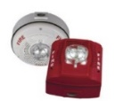
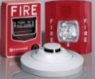
2022
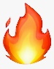
DATES: November 30 and December 1
PARK EAST
All Buildings (a,b,C,D,E,F,G,H,I,J,K,L)
START TIME: 8:30 A.M.
